1. Summary:

There are six questions.

The first two questions are called Independent Speaking Tasks because they require you to draw entirely on your own ideas, opinions, and experiences when responding.

The other four questions are Integrated Speaking Tasks. In these tasks you will listen to a conversation or to an excerpt from a lecture, or read a passage and then listen to a brief discussion or lecture excerpt, before you are asked the question.

These questions are called Integrated Tasks because they require that you integrate your English language skills—listening and speaking, or listening, reading, and speaking. In responding to these questions, you will be asked to base your spoken response on the information in the listening passage or on both the listening passage and the reading passage together

Tip:*1. For all the questions in the test you are given between 45 to 60 seconds to respond.  
So when practicing, time your speech accordingly.*

*2. For each of the six questions, you will be given a short time to prepare a response.*

*3. You will answer each of the questions by speaking into a microphone.*

*4. Your responses will be recorded and sent to a scoring center, and they will be scored by experienced raters.*

1. Scoring Rubrics:

Although scoring criteria vary somewhat depending on the question, the raters will generally be listening for the following features in your answer:

* Delivery: How clear your speech is. Good responses are those in which the speech is fluid and clear, with good pronunciation, natural pacing, and natural-sounding intonation patterns.
* Language Use: How effectively you use grammar and vocabulary to convey your ideas. Raters will be listening for how well you can control both basic and more complex language structures and use appropriate vocabulary.
* Topic Development: How fully you answer the question and how coherently you present your ideas. Good responses generally use all or most of the time allotted, and the relationship between ideas and the progression from one idea to the next is clear and easy to follow.

1. Questions:
2. 介绍及原因题：For this task, you will be asked to speak about a person, place, object, or event that is familiar to you.

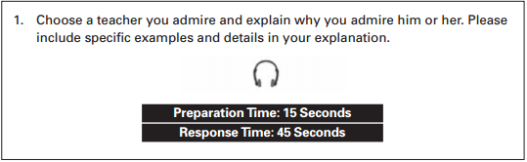

*Tip:Make a list of familiar topics, and practice speaking about them. You may want to  
begin by describing a familiar place or recounting a personal experience.*

1. 选择及理由题：

In this second Independent Speaking Task, you will be presented with two possible actions, situations, or opinions. Then you will be asked to say which of the  
actions or situations you think is preferable or which opinion you think is more  
justified and then explain your choice by providing reasons and details.

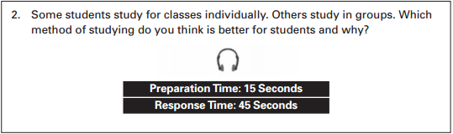

1. 读政策、听议论、转达观点
2. 看课程简介、听教授阐述：In this question you will read a short passage on an academic subject and then listen to a talk on the same topic. You will then answer a question using information from both the reading passage and the talk.

**Tip**: *Find listening and reading material on a topic that you like. The reading and the  
listening material can provide similar or different views. Take notes on what you  
listen to and read and create outlines. Use your notes and outlines to orally  
summarize the information and ideas from the listening and reading materials.  
Try to paraphrase what you have heard and read by using different words and  
grammatical structures.*

1. For question 5, you will listen to a short conversation about a campus-related situation In the conversation, two people will typically discuss a problem and two possible solutions. After you listen to the conversation, you will be asked to briefly describe the situation that was discussed in the conversation and to give your own opinion about solutions to the problem.

**Tip:** *It is very important to practice your conversational speaking skills as often as  
possible. One way of doing this might be joining an English language conversation  
club. If such clubs do not exist in your area, you may want to start your own and,  
if possible, invite native speakers to join in.*

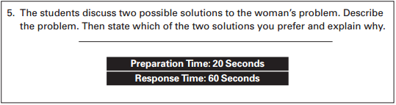

1. In this question, you will listen to part of a lecture. You will then be asked to summarize important information from the lecture.

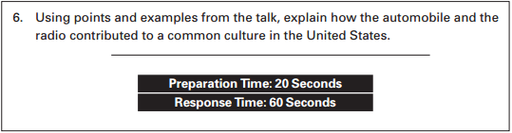

1. **TOEFL iBT Speaking Scoring Rubric：P187-190**